CS3343 Software Engineering Practice

Project title:

Service Plan Searching Assistant - Search It(SI)

Project Plan

Group Member:

Ng Chi Kin

Wu Wei Jian

Tsui Ka Kin

Tam Kwan Leong

Chan Ching Yi

Table of Contents

**Introduction** **3**

Project description 3

Objectivities 3

StakeHolders 3

**Software development methodology** **5**

**Role description** **5**

**Development tools** **6**

**Configuration management** **6**

**Work breakdown structure** **7**

**Project schedule(with Gantt chart)** **8**

**Deliverables** **9**

# Introduction

## Project description

In general, everyone will visit the service provider to collect the information of a service plan. In Hong Kong, there are 8 or above mobile service providers. Therefore, they need to visit the different service providers when they need to join a new plan or change a plan. For the general public, it is not efficiency. Moreover, the consumer needs to spend a lot of time viewing every service plan.

## Objectivities

The aims of the project is to solve the collecting service plans inefficient problem. For solving this problem, we will develop a self-service system. In this system, the consumer can get a list of service plan according to their requirements. Therefore, it can reduce their searching time. Also, it seems like a helping tool for consumer selecting a plan.

## StakeHolders

|  |  |  |
| --- | --- | --- |
| Position | Internal/ External | Description |
| Manager | Internal | The manager can create a new plan, delete the plan, and update it. Also, they can view the user’s service plan. |
| User | External | The user can search the service plan according to their requirement. Also, they can select a plan and check out it. |
| Developer | Internal | The developer can design the system structure, develop the system, and test the system. |

# Software development methodology

In the software life cycle, it has 3 components which are a set of activities, deliverables and quality control measures. For our project, we adopt the linear waterfall model.

Define the requirements

Design the solution

Maintain the system

Implement the solution

Test the system

# Role description

|  |  |  |
| --- | --- | --- |
| name | title | Job description |
| Ng Chi Kin | Project manager | Manage the project, develop the program |
| Wu Wei Jian | Software engineer | Develop the program |
| Tsui Ka Kin | Software engineer | Develop the program |
| Tam Kwan Leong | Software tester | Test the program |
| Chan Ching Yi | Software tester | Test the program |

# Development tools

|  |  |
| --- | --- |
| Tool | Purpose |
| Eclipse 4.8.0 | Develop a java program |
| JUnit 5 | Test the program |
| EclEmma 3.1 | Check testing coverage |
| GitHub | Version control and management |
| Google Drive | Storing the project document |
| Bugzilla | Write a bug report |

# Configuration management

Version controlling

We are using the GitHub to handle the version controlling. It allows us to develop the program at the same time. Moreover, we can visit what teammate did on each commit. Also, when the program is broken, we can go back to the previous version.

Document storing

Google drive is a tool for us to store and write all documents. With this platform, we can write the document together.

# Work breakdown structure

1. Project gathering
   1. Topic discussion
2. Project research
   1. Identify the user need
3. Analysis and design
   1. Function design
   2. Class diagram design
   3. Software structure design
4. Software development
   1. Client function development
      1. Plan searching (with conditions)
      2. Plan checking
      3. Plan checkout
   2. Manager function development
      1. Plan modification (add, update and delete)
      2. User’s plan checking
   3. Generic function
      1. Account registration
      2. Signing in
5. Testing
   1. Testing with JUnit
      1. Client function testing
         1. Plan searching (with conditions)
         2. Plan checking
         3. Plan checkout
      2. Manager function testing
         1. Plan modification (add, update and delete)
         2. User’s plan checking
      3. Generic function
         1. Account registration
         2. Signing in
   2. Testing program coverage
6. Debugging

# Project schedule (with Gantt chart)

|  |  |  |
| --- | --- | --- |
| tasks | Start date | End date |
| 1. Project gathering | 10/09/2018 | 10/09/2018 |
| 1.1 Topic discussion | 10/09/2018 | 10/09/2018 |
| 2. Project research | 17/09/2018 | 04/10/2018 |
| 2.1 Identify the user need | 17/09/2018 | 04/10/2018 |
| 3. Analysis and design | 08/10/2018 | 27/11/2018 |
| 3.1 Function design | 08/10/2018 | 11/10/2018 |
| 3.2 Class diagram design | 12/11/2018 | 21/11/2018 |
| 3.3 Software structure design | 12/10/2018 | 24/10/2018 |
| 4. Software development | 15/10/2018 | 21/11/2018 |
| 4.1 Client function development | 05/11/2018 | 19/11/2018 |
| 4.1.1 Plan searching (with conditions) | 05/11/2018 | 07/11/2018 |
| 4.1.2 Plan checking | 08/11/2018 | 12/11/2018 |
| 4.1.3 Plan checkout | 15/11/2018 | 19/11/2018 |
| 4.2 Manager function development | 06/11/2018 | 21/11/2018 |
| 4.2.1 Plan modification (add, update and delete) | 06/11/2018 | 08/11/2018 |
| 4.2.2 User’s plan checking | 19/11/2018 | 21/11/2018 |
| 4.3 Generic function | 15/10/2018 | 16/10/2018 |
| 4.3.1 Account registration | 15/10/2018 | 15/10/2018 |
| 4.3.2 Signing in | 16/10/2018 | 17/10/2018 |
| 5. Testing | 07/11/2018 | 28/11/2018 |
| 5.1 Testing with Junit | 07/11/2018 | 27/11/2018 |
| 5.1.1 Client function testing | 22/11/2018 | 26/11/2018 |
| 5.1.1.1 Plan searching (with conditions) | 22/11/2018 | 23/11/2018 |
| 5.1.1.2 Plan checking | 23/11/2018 | 23/11/2018 |
| 5.1.1.3 Plan checkout | 26/11/2018 | 26/11/2018 |
| 5.1.2 Manager function testing | 26/11/2018 | 27/11/2018 |
| 5.1.2.1 Plan modification (add, update and delete) | 26/11/2018 | 26/11/2018 |
| 5.1.2.2 User’s plan checking | 27/11/2018 | 27/11/2018 |
| 5.1.3 Generic function | 07/11/2018 | 07/11/2018 |
| 5.1.3.1 Account registration | 07/11/2018 | 07/11/2018 |
| 5.1.3.2 Signing in | 07/11/2018 | 07/11/2018 |
| 5.2 Testing program coverage | 22/11/2018 | 22/11/2018 |
| 6. Debugging | 22/11/2018 | 28/11/2018 |

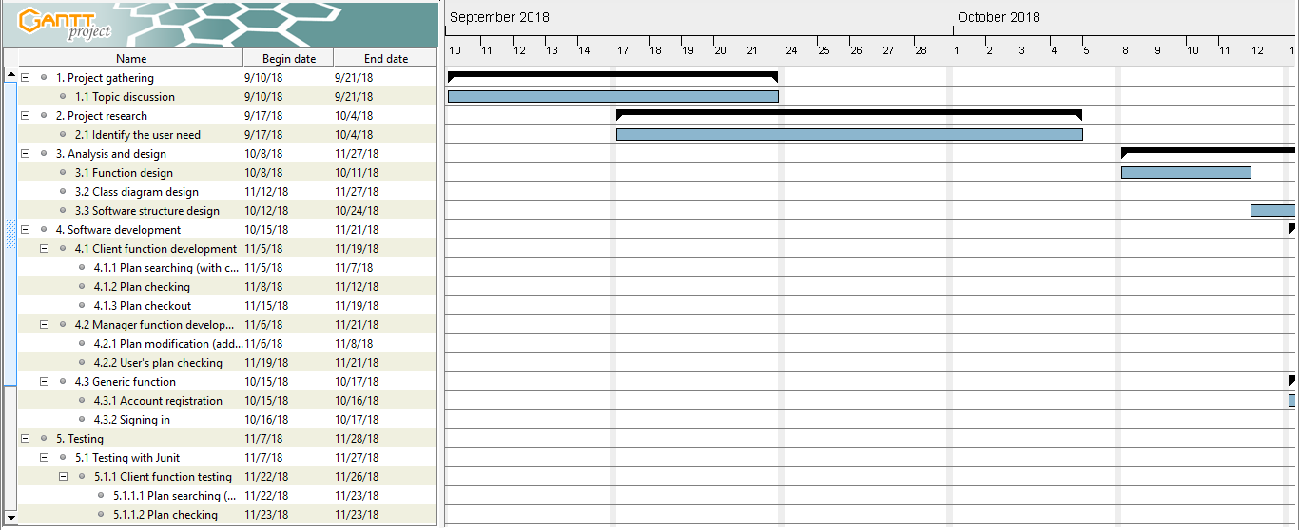

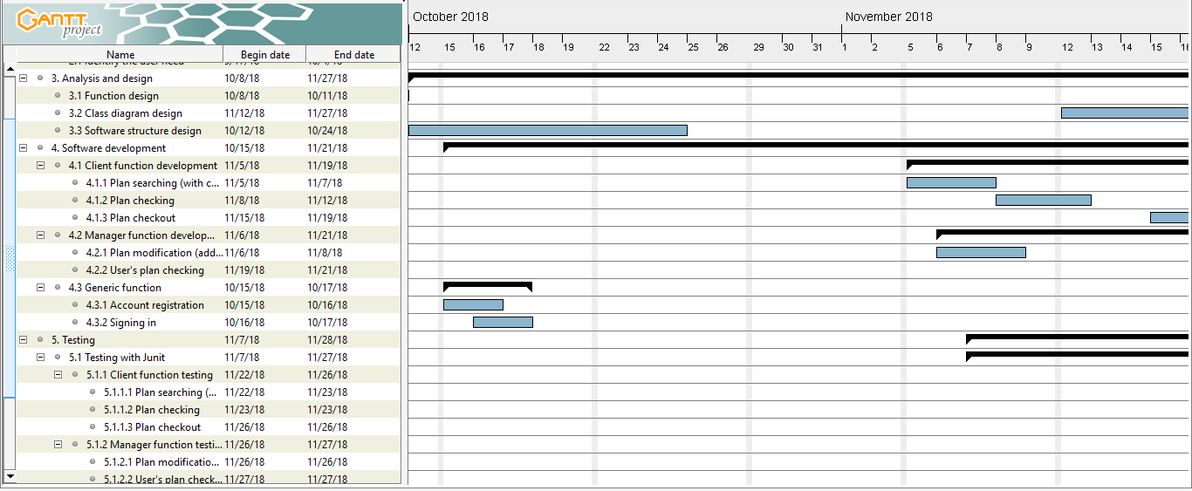

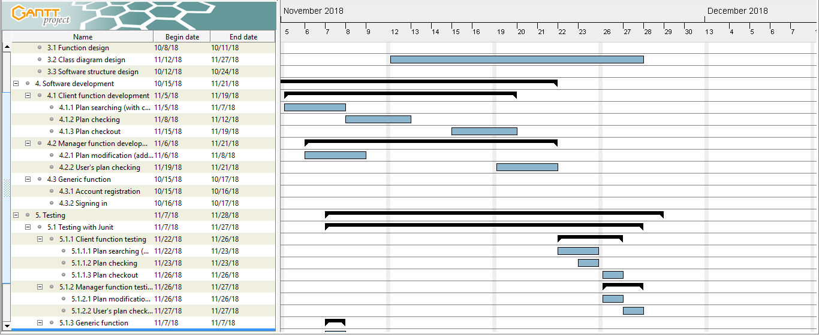

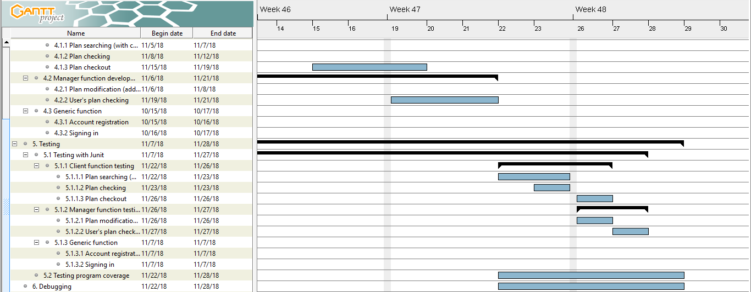

# Deliverables

The project is scheduled to finish development on 23 November 2018.